Derek Lee Deep Learning Fall 2020

Professor Curro Assignment #2

import numpy as np

import tensorflow as tf

import matplotlib.pyplot as plt

physical_devices = tf.config.list_physical_devices('GPU')

tf.config.experimental.set_memory_growth(physical_devices[0], True)

# Constants

N = 200

sigNoise = 0.1

M = 128         # Base dimension for w

numEpochs = 200

learnRate = 0.1

alpha = 0.001   # Penalty term for L2 Regularization

# Parameters for Spirals

a = [ 2, -2 ]

b = [ 1, -1 ]

t = tf.random.uniform( [2, N, 1], 0.25, 3.5*np.pi )

eps = tf.random.normal( [4, N, 1], 0, sigNoise )

# Spirals

x = ( a[0] + b[0] * t[0] ) * tf.cos( t[0] ) + eps[0]

y = ( a[0] + b[0] * t[0] ) * tf.sin( t[0] ) + eps[1]

x2 = ( a[1] + b[1] * t[1] ) * tf.cos( t[1] ) + eps[2]

y2 = ( a[1] + b[1] * t[1] ) * tf.sin( t[1] ) + eps[3]

# Creating training data

    # Class labels

classZero = tf.constant( 0, shape = [N,1], dtype = tf.float32 )

classOne = tf.constant( 1, shape = [N,1], dtype = tf.float32 )

    # Combine x and y into an input

xTrain = tf.concat( [ x, y ], 1 )

x2Train = tf.concat( [ x2, y2 ], 1 )

trainInput = tf.concat( [ xTrain, x2Train ], 0 )

trainOutput = tf.concat( [ classZero, classOne ], 0 )

    # Randomize

train = tf.concat( [ trainInput, trainOutput ], 1 )

train = tf.random.shuffle( train )

trainInput = train[ :, :-1 ]

trainOutput = train[ :, -1, np.newaxis ]

# Weight initialization inspired by:

# https://stats.stackexchange.com/questions/47590/what-are-good-initial-weights-in-a-neural-network

#   Used Glorot initialization, except with normal rather than uniform distribution

wInputs = np.array( [ 2, M, M//4, M//16 ] )

wOutputs = np.array( [ wInputs[1], wInputs[2], wInputs[3],  1 ] )

wInputs = wInputs[ :, np.newaxis ]

wOutputs = wOutputs[ :, np.newaxis ]

r = 2 * np.sqrt( 6 / ( wInputs + wOutputs ) )

bRanges = np.array( [ 1, 1, 1, 1, 1 ] )

# Module containing Logistic Classification model

class logClassMod( tf.Module ):

    def __init__( self ):

        # Trainable Tensorflow variables

        self.w0 = tf.Variable( tf.random.uniform( [ wInputs[0][0], wOutputs[0][0] ], -r[0], r[0] ) )

        self.w1 = tf.Variable( tf.random.uniform( [ wInputs[1][0], wOutputs[1][0] ], -r[1], r[1] ) )

        self.w2 = tf.Variable( tf.random.uniform( [ wInputs[2][0], wOutputs[2][0] ], -r[2], r[2] ) )

        self.w3 = tf.Variable( tf.random.uniform( [ wInputs[3][0], wOutputs[3][0] ], -r[3], r[3] ) )

        self.b0 = tf.Variable( tf.random.normal( [ wOutputs[0][0] ], -bRanges[0], bRanges[0] ) )

        self.b1 = tf.Variable( tf.random.normal( [ wOutputs[1][0] ], -bRanges[1], bRanges[1] ) )

        self.b2 = tf.Variable( tf.random.normal( [ wOutputs[2][0] ], -bRanges[2], bRanges[2] ) )

        self.b3 = tf.Variable( tf.random.normal( [ wOutputs[3][0] ], -bRanges[3], bRanges[3] ) )

        self.weights = [ self.w0, self.w1, self.w2, self.w3 ]

        self.biases  = [ self.b0, self.b1, self.b2, self.b3 ]

    # Calculates yHat given x

    # Uses multilayer perceptron

    @tf.function

    def estY( self, x ):

        tempX = x

        for i in range( len( self.weights ) ):

            tempX = tempX @ self.weights[i] + self.biases[i]

            if i != len( self.weights ) - 1:

                tempX = self.elu( tempX )

            else:

                return self.sigmoid( tempX )

    @tf.function

    def elu( self, x ):

        eluAlpha = 0.5

        return tf.where( x >= 0, x, eluAlpha * ( tf.exp(x) - 1 ) )  # eLU

    # Sigmoid function to get activation levels

    @tf.function

    def sigmoid( self, x ):

        return 1 / ( 1 + tf.exp( -x ) )

    def train( self ):

        # Stochastic Gradient Descent

        opt = tf.keras.optimizers.SGD( learning_rate = learnRate )

        # Binary Cross Entropy

        bce = tf.keras.losses.BinaryCrossentropy()

        print( "Starting Loss (Unregularized):", bce( self.estY( trainInput ), trainOutput ).numpy() )

        # Iterate through epochs

        for _ in range( numEpochs ):

            with tf.GradientTape() as tape:

                yHat = self.estY( trainInput )

                loss = bce( trainOutput, yHat )

                # L2 Regularization

                for i in self.weights:

                    regularizer = tf.nn.l2_loss( i )

                    loss += alpha * regularizer

                print(loss)

            grads = tape.gradient( loss, self.variables )

            opt.apply_gradients( zip( grads, self.variables ) )

        print( "Final Loss (Unregularized):", bce( self.estY( trainInput ), trainOutput ).numpy() )

    def plotSpirals( self ):

        # Create true input data

        xTrue, yTrue = np.meshgrid( tf.cast( tf.linspace( -15, 15, 100 ), tf.float32 ), tf.cast( tf.linspace( -15, 15, 100 ), tf.float32 ) )

        xTrueCol = xTrue.flatten()

        xTrueCol = xTrueCol[ :, np.newaxis ]

        yTrueCol = yTrue.flatten()

        yTrueCol = yTrueCol[ :, np.newaxis ]

        trueInput = tf.concat( [ xTrueCol, yTrueCol ], 1 )

        # Calculate output

        trueOutput = self.estY( trueInput )

        # Plot boundary

        plt.figure()

        conPlot = plt.contourf( xTrue, yTrue, np.reshape( trueOutput, xTrue.shape ), levels = [ 0.45, 0.55 ] )

        plt.colorbar( conPlot )

        # Plot spirals

        plt.plot( x, y, 'ro', markeredgecolor = 'black' )

        plt.plot( x2, y2, 'bo', markeredgecolor = 'black' )

        plt.xlabel( 'x' )

        plt.ylabel( 'y', rotation = 0 )

        plt.title( "Spirals" )

        plt.show()

def main():

    # Ensure input data is valid

    assert not np.any( np.isnan( trainInput ) )

    assert not np.any( np.isnan( trainOutput ) )

    model = logClassMod()

    # Training

    model.train()

    # Get predictions

    yHat = model.estY( trainInput )

    yPred = tf.where( yHat >= 0.5, float(1), float(0) )

    z = tf.math.equal( trainOutput, yPred )

    print( "Number of 1's: ", tf.reduce_sum( yPred ).numpy() )

    print( "% Correct: ", ( tf.reduce_sum(tf.cast(z, tf.float32))/len(z) ).numpy()*100 )

    # Plot boundary between classes

    model.plotSpirals()

main()

My f was relatively consistent throughout the assignment. I initially used a ReLU as my nonlinear function, but quickly moved to an eLU instead. I use a sigmoid as my activation function. I played around with my learning rate, but it did not have a significant effect on my model (except when it was so high that it caused nan values).

I started off with 3 layers of weights, the first 2 mapping between R2 and R2, with the final layer mapping from R2 to R1. Initially, I did not have much success. This did not do much better than random guessing (and in some cases, did worse). Next, I tried an additional layer, along with mapping to different dimensions with every layer. I mapped from R2 to R64 to R32 to R4 to R1. Additionally, I researched how to initialize my weights and learned about Glorot initialization. This was better, but still not very successful. I achieved around a 70% accuracy. Finally, I tried changing the initializations of my biases. I had my biases initialized to 0, but I changed it to a normal distribution, with mean -1 and standard deviation 1. I also changed the dimensions of my weights. I mapped from R2 to R128 to R32 to R8 to R1. This gave me the greatest success. Although changing the biases gave me a significant improvement in my accuracy, changing the dimensions of my weights gave me consistency. I consistently achieve accuracy in the high 90s, if not perfect.

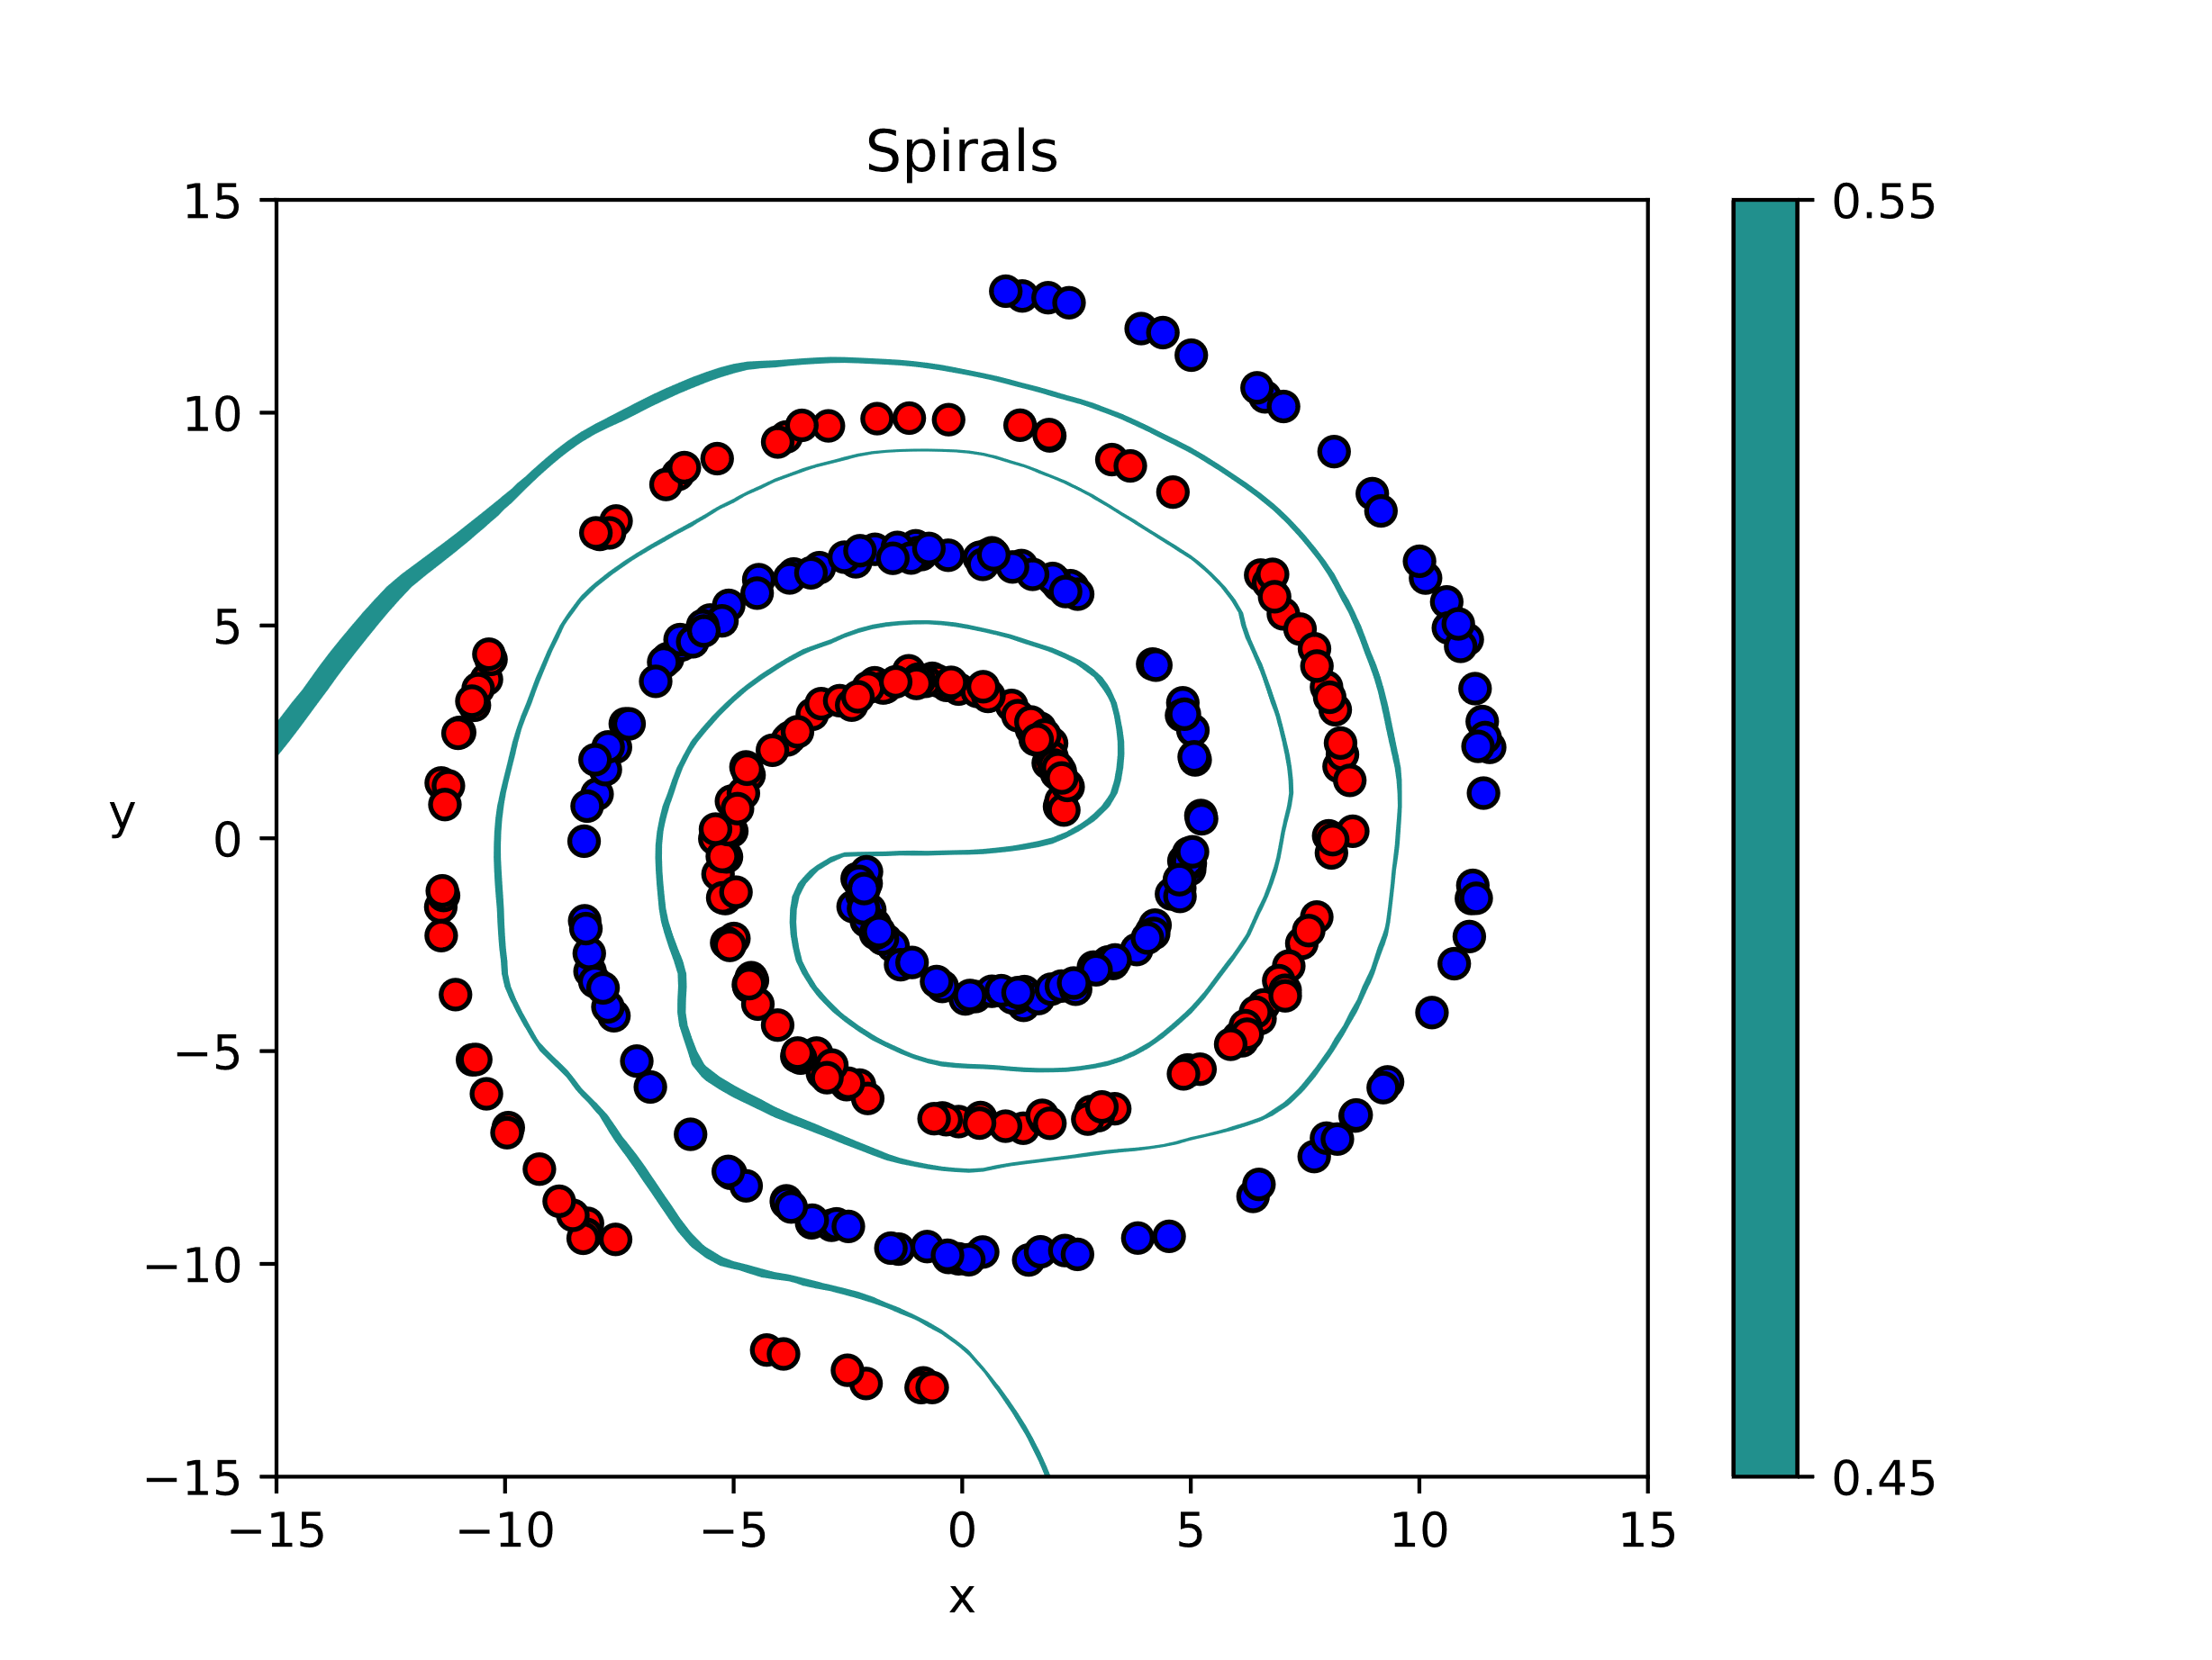

Figure 1: Example plot for the boundary of the logistic classification of two spirals using a multilayer perceptron